* Login into AWS console from event engine dashboard

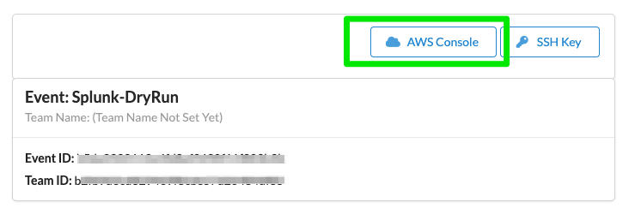

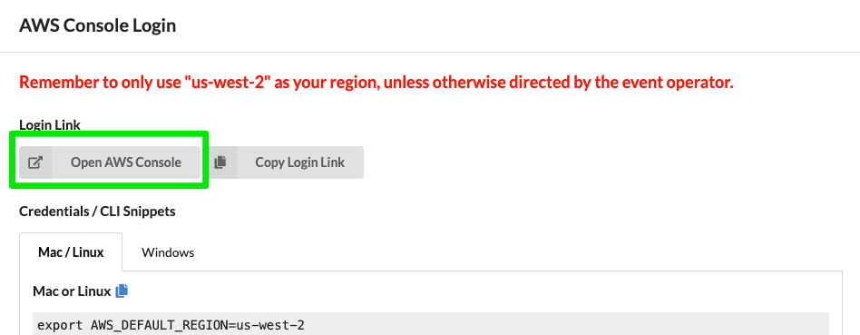

* Select EC2 from Management console and select Instances(running). You should see a EC2 instance named **SignalFxWorkshop-box**

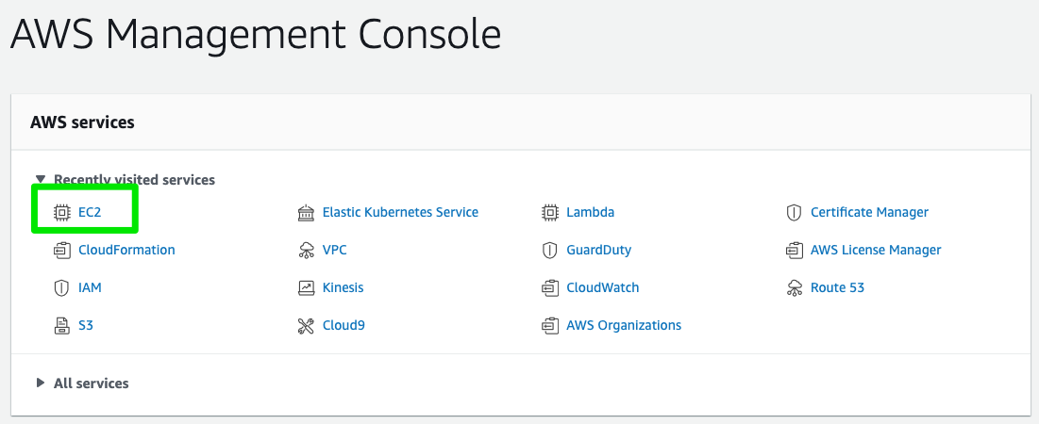

* Now select the **SignalFxWorkshop-box** instance and select connect

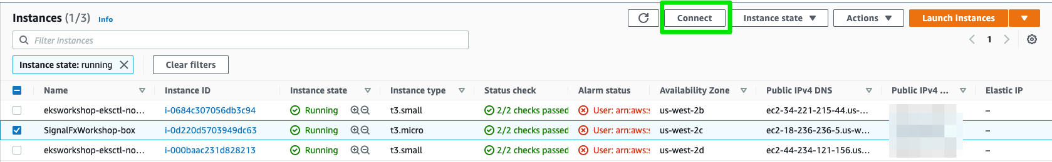

* Select EC2 Instance Connect tab and click connect. This will open an SSH session to the EC2 instance. Once the instance is opened check the running EKS cluster. You should see a cluster named **eksworkshop-eksctl** running
* eksctl get cluster
* Update kubectl configuration
* aws eks --region us-west-2 update-kubeconfig --name eksworkshop-eksctl
* Test kubectl
* kubectl get nodes # if we see our 2 nodes, we know we have authenticated correctly
* Download SignalFX workshop
* wget https://github.com/amitsharm/o11yworkshop/archive/master.zip
* unzip master.zip
* Install Helm
* curl -fsSL -o get_helm.sh https://raw.githubusercontent.com/helm/helm/master/scripts/get-helm-3
* chmod 700 get_helm.sh
* ./get_helm.sh
  + If you Getting following error message
  + In order to verify checksum, openssl must first be installed.
  + Please install openssl or set VERIFY_CHECKSUM=false in your environment.
  + Failed to install helm
  + For support, go to <https://github.com/helm/helm>.
  + Export the variable VERIFY_CHECKSUM as
  + export VERIFY_CHECKSUM=false